***Source-to-Pay (S2P)***

Source-to-pay (S2P) is a process that starts with finding, negotiating with, and contracting the supplier of goods, and culminates in final payment for those goods.

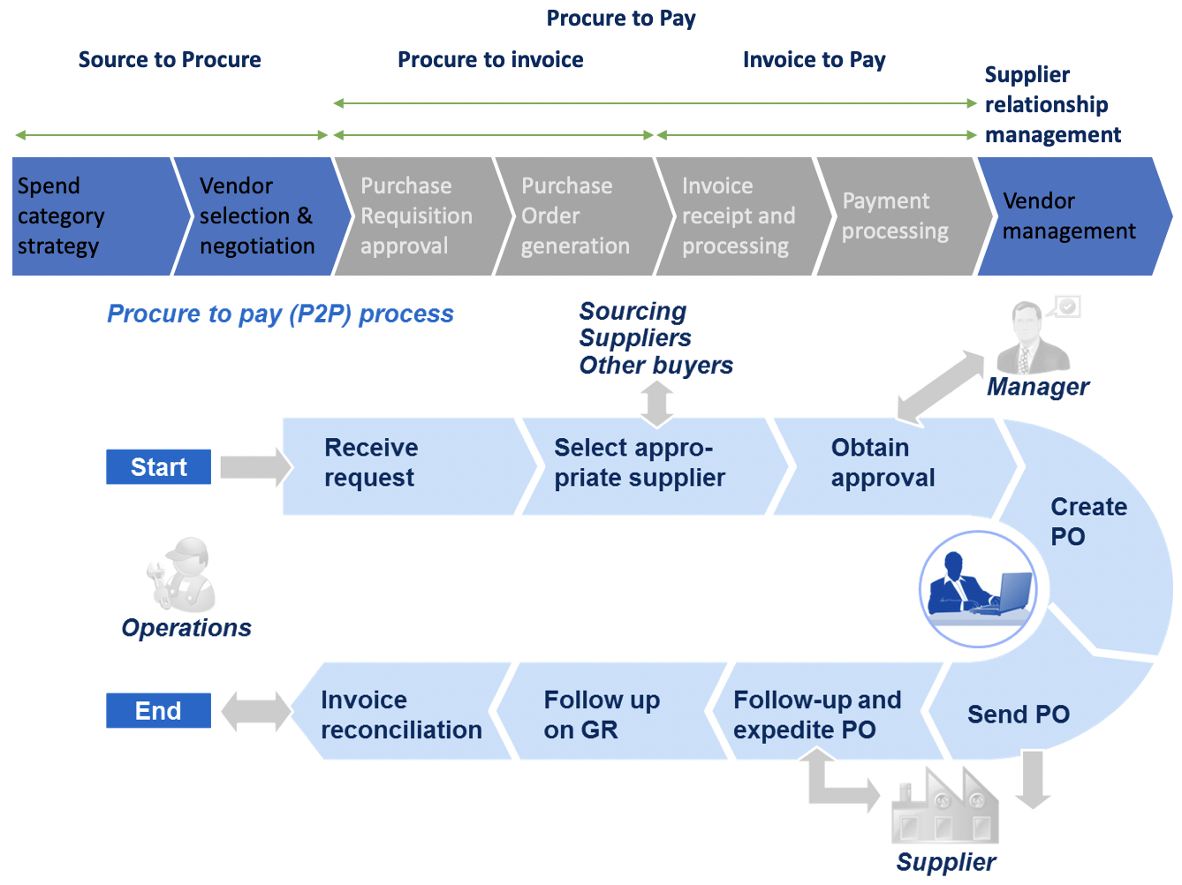

S2P software relies on technology, big data, and digital networks to create procurement efficiency. Rather than treating procurement as a series of disparate tasks, best-in-class organizations aggregate purchases across business units to improve performance, provide better spend analysis, and drive business value. Usual benefits of source-to-pay platform include:

* Higher sourcing savings through increased visibility into procurement
* Integration of key processes into a single platform to get to signed-contracts faster
* Stronger procedural, regulatory, and contractual compliance
* Improved collaboration, trust, and spend among trading partners
* Better pricing and have more accurate forecasting leveraging data

***Types of Costs involved in Procurement:***

1. Base Cost of items:

The key procurement cost driver is the per-item amount. In larger transactions, this is especially true. It is the largest expense and the most challenging to reduce. The best move is to find competing suppliers with the same products and negotiate the best price per unit.

2. Cost of Transportation (Freight):

Transportation expenses are direct stock-acquiring costs. Developing flexible and long-term relationships with carriers is one way to negotiate terms for bettering shipping rates.

3. Closing Cost:

Many companies outsource the buying and selling of inventory, which means that expenses such as brokerage, legal fees (when legal advisors are hired to draft contracts), and commissions may add up.

4. Taxes and Duties

For inventory acquired overseas, there are considerable costs associated such as government charges like tariffs, taxes as flat rates (like VAT or GST), and more. Import taxes can be more complex than just flat tax rates.

***Types of Events in Procurement:***

1. Reverse Auction

Buyers make requests for goods or services and suppliers then place bids that reflect the amount they are willing to be paid for providing the goods or services. Once the auction is complete the Supplier with the lowest bid wins.

1. Forward Auction

Forward auctions allow you to create your own marketplace for your goods to increase sales. Bidders compete in real-time until the auction is complete, guaranteeing good value for the Supplier. The item is awarded to the highest Bidder.

1. Dutch Auctions

During a Dutch Auction the item price is lowered until a Buyer is prepared to place a bid. If the Reserve Price has been met the first bid received is considered the winning bid and automatically results in a sale.

1. Japanese Auction

Bidders’ must accept the opening price, defined by the Buyer, in order to be able to participate in the auction. By accepting the opening price the Bidder is agreeing to supply the goods or services for the price defined by the Buyer. As Bidders’ agree to prices, the bid price is reduced at pre-defined intervals and Bidders are prompted to accept or reject the new price. This continues until there is only one Bidder remaining.

1. Multi-lot Auction

During a Multi-lot Auction the Supplier will list multiple identical items, or lots, to multiple Buyers. Winners are determined by sorting all the bids from highest to lowest. The winners’ then pay the lowest amount they bid over the Reserve. Bidders’ are entitled to refuse lots if they aren’t given the quantities they requested. Bidders’ with higher bids are given priority when allocating lots. If there are more successful Bidders than lots the Bidders who submitted first will be awarded the items.

1. RFP – Request for Proposal:

A Request for Proposal, or RFP, is a document that companies use to gather information about services from a potential supplier or contractor. These documents are more complicated than RFQs since they ask for more than just a price.

Since the document is a request for services, not products, the information contained in the RFP is more detailed than information in an RFQ. The RFP will detail the goals and nature of the project that the company needs completed. In addition, it will detail the number of pages and illustrations that the proposal should contain, what laws the project is subject to, and what qualifications the contractors should have. The company may request the proposal contain other information as well, depending on the project.

In return, the potential contractor will submit a proposal detailing:

* What the contractor needs for project completion
* The estimated costs of labor
* The estimated costs of management and other fees
* The total project cost

The company will use this proposal to decide whether to hire that contractor. Companies who lack the expertise to detail the scope of the project they want to complete use RFPs to solicit assistance from more knowledgeable contractors.

For example, imagine that a corporation is looking to open a new store location in a different state. They need to find a contractor to renovate their property to match the design of their other locations. They will send an RFP to various contractors in the area detailing the nature and goals of the project, the different building codes that the contractor will have

to adhere to, the company’s style guide, and the licensing requirements the company is seeking. Contractors will return proposals to this company and the company will select the best proposal for hire.

1. RFQ – Request for Quotation:

A Request for Quote, or RFQ, is a document that companies use to gather information about goods from the potential vendor. Before the procurement of these goods, this document explains that the company wishes to purchase a certain type and amount of goods from a vendor. The RFQ will detail the specifications and quantities of those goods.

The company will send the RFQ to specific companies they are interested in working with. In response, potential vendors will send quotes and price estimates to the company who put the RFQ out. From these responses, the company can choose which vendor can provide the best products at the best prices. Usually, a company uses an RFQ if they need to make a large-scale purchase.

For example, imagine that an office is in the market to purchase a large quantity of paper for an upcoming conference. They need to purchase 2,500 reams and are trying to find the best price for their project. The office will send an RFQ to various paper suppliers in their area to find the best quote for the amount they need.

RFQ may also stand for “Request for Qualifications.” Companies use this document to solicit vendor and contractor qualifications to narrow down choices for a project bid.

1. RFI – Request for Information:

RFI stands for Request for Information. Companies use RFIs to gather information on what steps to take next in a contract negotiation. Usually, RFIs are the last stage in the RFQ or RFP process.

Some of the existing S2P solutions include:

**Competitors:**

Aavenir - <https://aavenir.com/>

FairMarkit - <https://www.fairmarkit.com/>

Coupa - <https://www.coupa.com/>

SAP Ariba - <https://www.ariba.com/>

Procoto - <https://procoto.com/>

Jaggaer - <https://www.jaggaer.com/>

iValua - <https://www.ivalua.com/>

Penny – <https://penny.co/>

Procurify - <https://www.procurify.com/>

KissFlow - <https://kissflow.com/procurement/>

RFP360 - <https://rfp360.com/>

**Links to Product Demos:**

Aavenir - <https://aavenir.com/resources/roi-calculator-for-accounts-payable-automation/>

Fairmarkit -

<https://vimeo.com/481843897>

<https://www.fairmarkit.com/resources/sourcing-simulator>

<https://www.fairmarkit.com/resources/savings-calculator>

Coupa - <https://videos.coupa.com/watch/k4zmYv1HEaMLSc8hyNJAAQ>

SAP Ariba -

Navigating through the interface - <https://www.youtube.com/watch?v=DCb1BzPc5n4>

Creating an event - <https://www.youtube.com/watch?v=SNCfzIIiKYk>

Some additional resources to understand the S2P industry:

1. McKinsey Report: Revolutionizing indirect procurement for the 2020s

(<https://www.mckinsey.com/business-functions/operations/our-insights/revolutionizing-indirect-procurement-for-the-2020s>)

1. McKinsey Report: A next-generation operating model for source-to-pay

(<https://www.mckinsey.com/business-functions/operations/our-insights/a-next-generation-operating-model-for-source-to-pay>)

1. McKinsey Report: A road map for digitizing source-to-pay

(<https://www.mckinsey.com/business-functions/operations/our-insights/a-road-map-for-digitizing-source-to-pay>)

1. Gartner Report: Comparison between S2P software for various industries:

(<https://www.gartner.com/reviews/market/procure-to-pay-suites>)

1. Gartner Report – S2P Magic Quadrant Comparisons (Attached – in the drive)